PayPal Business Intelligence Project
(End-to-End BI Solution: Data Preparation, Modeling, Dashboards & Insights)

Course: Business Intelligence and database management

Instructor: Dr Ameni Azzouz

Prepared by: Shayma Khiari
Imen Saad
Achref Khaled
Roudayna Azizi

Academic Year: 2025–2026

Introduction 3
BUSINESS CONTEXT & PROBLEM STATEMENT 4
PROJECT OBJECTIVES 5
DATA OVERVIEW 6
ETL PROCESS 7
DATA QUALITY & CLEANING 8
DATA MODELING (STAR SCHEMA) 9
MEASURES & KPIs 11
DASHBOARD DEVELOPMENT 12
DEEP DIVE DASHBOARD 13
KEY FINDINGS 14
BUSINESS INTERPRETATION 15
BUSINESS RECOMMENDATIONS 16
LIMITATIONS 17
FUTURE IMPROVEMENTS 18
CONCLUSION 19
APPENDIX 20

Introduction

Business Intelligence plays a crucial role in enabling organizations to analyze large volumes of data and transform them into actionable insights. In the context of digital payment platforms such as PayPal, Business Intelligence is essential for monitoring transaction performance, understanding customer behavior, and detecting potential fraud risks in a timely manner.
This project presents an end-to-end Business Intelligence solution applied to PayPal
transaction data. The project follows a structured BI lifecycle, starting with raw data extraction and cleaning using Python, followed by dimensional modeling and dashboard development using Power BI. The final objective is to generate insights and business recommendations that support data-driven decision-making.
The report details each phase of the project, including the ETL process implemented in Python, the star schema data model, the creation of DAX measures, the development of interactive dashboards in Power BI, and the interpretation of results. By combining technical implementation with business analysis, this project demonstrates the practical value of Business Intelligence tools in a real-world business scenario.

BUSINESS CONTEXT & PROBLEM STATEMENT

PayPal is a global digital payment platform that enables individuals and businesses to send and receive payments electronically across multiple countries and currencies. As the volume of online transactions continues to grow, PayPal must manage complex transaction flows involving different payment methods, merchant categories, and geographic regions. Ensuring transaction efficiency and minimizing fraud are essential to maintaining customer trust and competitive advantage.
One of the major challenges faced by PayPal is the ability to monitor transaction performance in a comprehensive and timely manner. Decision-makers need visibility into key indicators such as transaction volume, transaction value, success rates, and fraud levels. Without a centralized Business Intelligence solution, this information remains fragmented and difficult to analyze, increasing the risk of delayed or suboptimal decisions.
The problem addressed by this project is the lack of an integrated analytical view that allows stakeholders to monitor transaction performance and identify risks effectively. By implementing a Business Intelligence solution, PayPal can improve transparency, enhance fraud monitoring, and support data-driven decision-making at both strategic and operational levels.

PROJECT OBJECTIVES

The primary objective of this Business Intelligence project is to design and implement an analytical solution that supports the monitoring and analysis of PayPal transaction data. This objective is achieved through several specific goals.
First, the project aims to analyze transaction performance in terms of volume and monetary value in order to understand overall business activity. Second, it seeks to identify trends and patterns related to customer payment behavior and preferred payment methods. Third, the project evaluates transaction performance across different countries and merchant categories to highlight key markets and revenue drivers.
Additionally, the project focuses on monitoring fraud indicators in order to identify potential risk areas and support proactive fraud management. Finally, the project aims to present insights through interactive dashboards that enable users to explore data dynamically and support informed decision-making.

DATA OVERVIEW

The dataset used in this project consists of a simulated PayPal transaction dataset designed to represent realistic business scenarios. The dataset includes transactional information such as transaction identifiers, transaction dates, transaction amounts, transaction fees, countries, payment methods, merchant categories, transaction status, and fraud indicators.
The dataset is structured in a tabular format suitable for analytical processing and Business Intelligence applications. Each record represents a single transaction, allowing detailed analysis at both aggregate and granular levels. The use of simulated data ensures compliance with privacy and confidentiality constraints while still providing a realistic foundation for analysis.
This dataset was selected because it supports the objectives of the project and enables the exploration of transaction performance, geographic distribution, payment behavior, and fraud patterns.

ETL PROCESS
An ETL (Extract, Transform, Load) process was implemented using Python to ensure data quality and prepare the dataset for analytical use. Python was selected due to its flexibility, efficiency, and strong ecosystem of data processing libraries, such as pandas and numpy.
During the extract phase, the raw PayPal transaction data was imported from CSV files into a Python environment. This step ensured direct access to the original dataset and allowed full control over data preprocessing operations.
The transform phase involved several critical data cleaning steps. Duplicate transactions were identified and removed to prevent double counting. Missing values were analyzed and handled to maintain data consistency. Data types were standardized, particularly for date and numerical fields, to ensure compatibility with analytical tools. Additionally, categorical fields such as payment method and transaction status were reviewed for consistency.
In the load phase, the cleaned dataset was exported from Python and saved as a clean CSV file. This file was then loaded into Power BI, ensuring that only validated and high-quality data was used for modeling and dashboard development.

DATA QUALITY & CLEANING

Data quality is a fundamental requirement for any Business Intelligence solution. Poor data quality can lead to inaccurate insights and unreliable conclusions. In the raw dataset, several quality issues were identified, including duplicate records, missing values, and inconsistent data formats.
To address these issues, data cleaning techniques were applied during the ETL process. Duplicate transactions were removed to ensure accurate transaction counts. Missing values were reviewed and handled to minimize their impact on analysis. Numerical fields such as transaction amounts were validated to ensure they contained meaningful values.
By applying these data quality measures, the dataset became more consistent and reliable, allowing accurate calculation of KPIs and meaningful interpretation of results.

DATA MODELING (STAR SCHEMA)

Following the completion of the ETL process and the preparation of a clean and reliable dataset using Python, the next step of the Business Intelligence lifecycle was data modeling. The objective of this phase was to design a data structure that supports efficient analytical queries, simplifies reporting, and enables intuitive exploration of PayPal transaction data.
A dimensional star schema was selected as the data modeling approach for this project. This modeling technique is widely used in Business Intelligence environments due to its simplicity, high performance, and ease of use for analytical and reporting purposes. The star schema allows decision-makers to analyze large volumes of transactional data efficiently while maintaining clarity in the relationship between facts and dimensions.
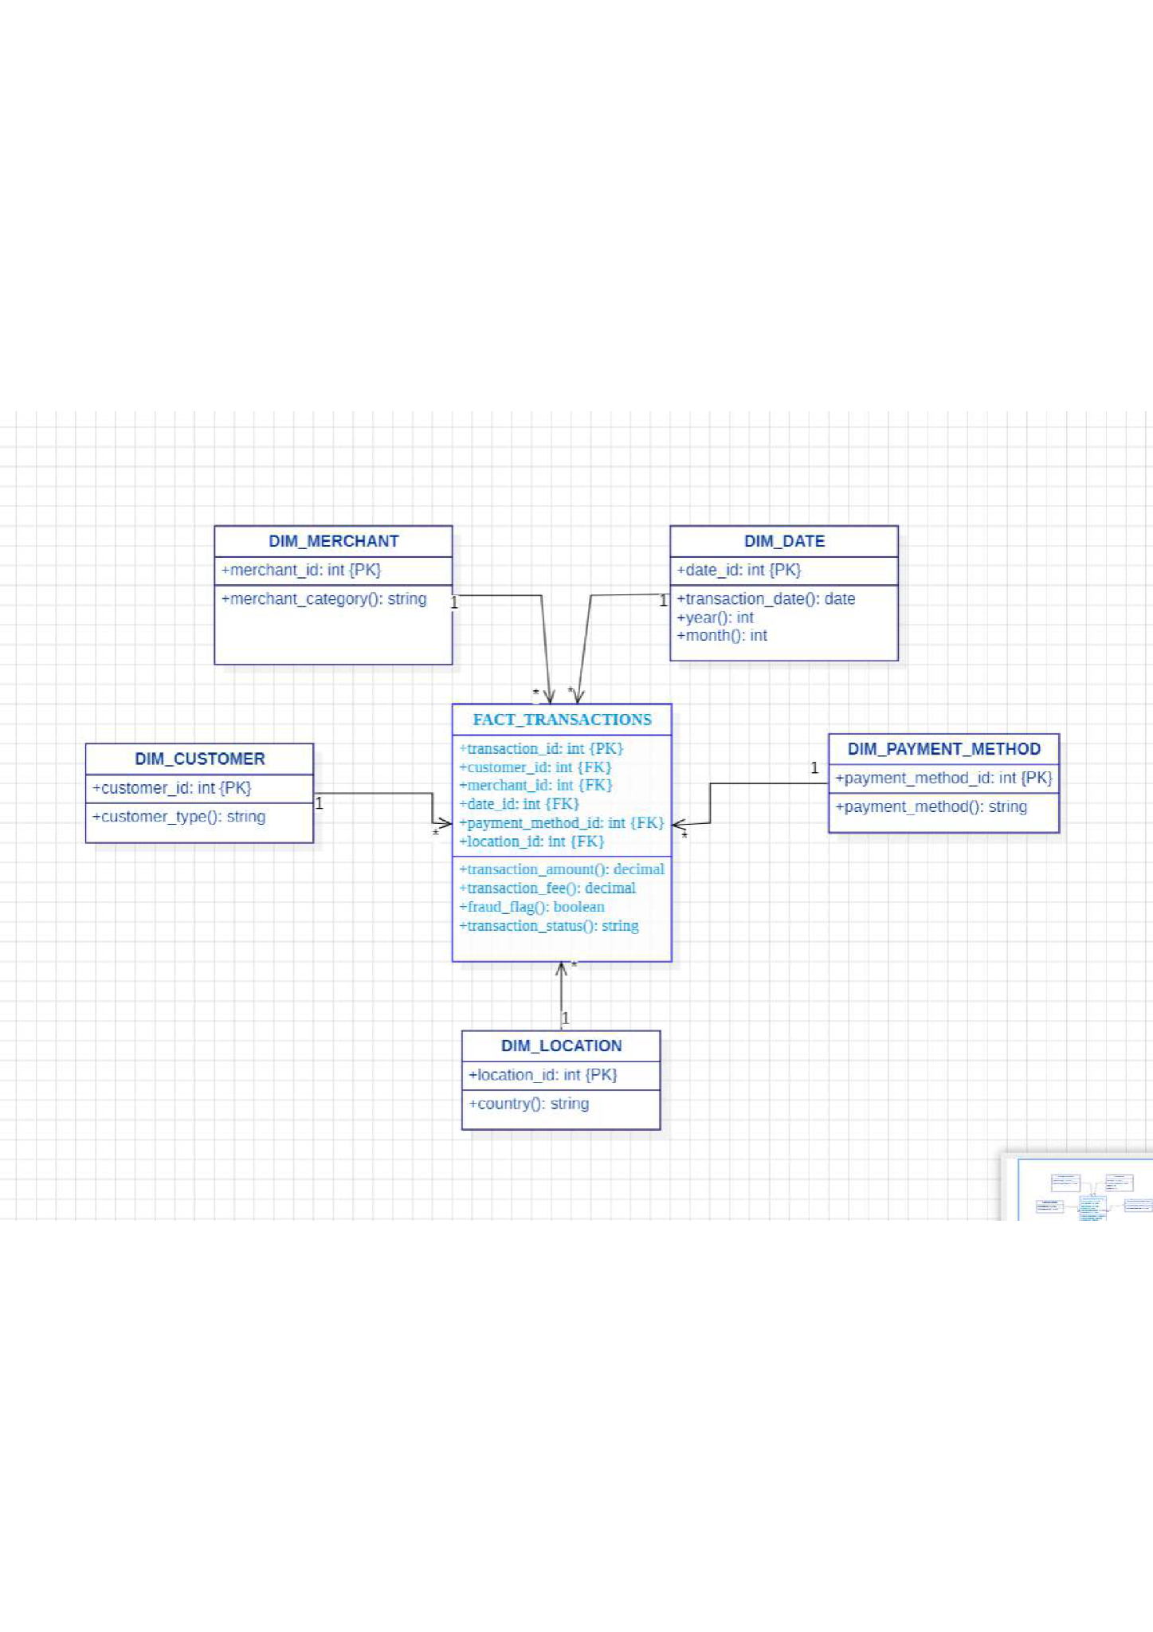
The model is centered around a Transaction Fact Table, which stores quantitative and measurable attributes related to PayPal transactions. These measures include transaction amount, transaction fee, and fraud indicator. Each record in the fact table represents a single transaction event, making it possible to perform detailed and aggregated analysis.
Surrounding the fact table are several dimension tables, which provide descriptive context and enable slicing and filtering of data. The Date Dimension allows analysis across different time levels such as year, month, and day. The Country Dimension enables geographic analysis of transactions and identification of high-performing or high-risk regions. The Payment Method Dimension provides insights into customer payment preferences, while the Merchant Category Dimension supports analysis across different business sectors.
The star schema was designed to ensure clear and simple relationships between the fact table and dimension tables, with each dimension connected directly to the central fact table. This structure minimizes query complexity and improves performance, especially when working with large datasets in analytical tools such as Power BI.
The dimensional model served as the foundation for dashboard development and DAX measure creation in Power BI. By adopting a star schema, the project ensures scalability, analytical flexibility, and alignment with Business Intelligence best practices, enabling effective data exploration and decision support.

MEASURES & KPIs

Key Performance Indicators (KPIs) were created using DAX (Data Analysis Expressions) within Power BI. DAX was used to define business metrics that are dynamically recalculated based on user filters and slicers.
The main measures include total number of transactions, total transaction value, average transaction amount, and fraud rate. These measures enable consistent performance tracking across different dimensions such as time, country, and payment method. By using DAX, the dashboards provide interactive and real-time analytical capabilities.
These KPIs serve as the foundation for both the Executive Summary and Deep Dive dashboards.

DASHBOARD DEVELOPMENT

Dashboard development was carried out using Power BI Desktop, which was selected for its powerful visualization capabilities and ease of integration with structured datasets. Two dashboards were developed to address different analytical needs.
The Executive Summary dashboard provides a high-level overview of PayPal’s transaction performance. It includes KPI cards, trend charts, and summary breakdowns designed for senior management. This dashboard enables quick assessment of overall performance and key risks.
Interactive slicers were added to allow users to filter data by date, country, and payment method, enhancing exploratory analysis.

DEEP DIVE DASHBOARD

The Deep Dive dashboard focuses on detailed analysis and is intended for analysts and operational teams. This dashboard allows in-depth exploration of transaction behavior by payment method, country, and merchant category.
Visualizations such as bar charts, column charts, and tables were used to compare performance across different segments. This dashboard supports root-cause analysis and helps identify patterns that are not visible at a high level.
Together, the two dashboards provide a comprehensive analytical view that supports both strategic and operational decision-making.

KEY FINDINGS

The insights presented in this section are derived directly from the Power BI dashboards. Analysis of transaction trends reveals stable transaction volumes with periodic peaks, indicating predictable variations in user activity.
The dashboards also show that a small number of payment methods dominate transaction volume, highlighting customer preferences. Geographic analysis reveals significant differences in transaction value across countries, indicating the presence of key revenue-generating markets.
Fraud analysis shows that while the overall fraud rate is low, certain segments exhibit higher risk. These findings demonstrate the effectiveness of Power BI dashboards in identifying both performance drivers and risk areas.

BUSINESS INTERPRETATION

These findings provide valuable insights into PayPal’s operational performance and strategic positioning. Understanding transaction trends enables better demand forecasting and resource allocation. Identifying preferred payment methods allows PayPal to prioritize system stability and innovation where it matters most.
Geographic insights support market prioritization and expansion strategies, while fraud analysis reinforces the importance of proactive risk management. Together, these insights demonstrate how Business Intelligence can directly support business strategy and operational efficiency.

BUSINESS RECOMMENDATIONS

Based on the analysis, several business recommendations are proposed. PayPal should prioritize the optimization of high-usage payment methods to enhance reliability and user experience. Strengthening fraud detection mechanisms in high-risk segments can further reduce financial and reputational risk.
Additionally, PayPal should focus growth strategies on high-performing countries while investigating the causes of failed transactions to improve success rates. Leveraging transaction trends can also support more effective marketing and promotional planning

LIMITATIONS

This project has several limitations that should be acknowledged. The dataset used is simulated and does not represent real PayPal transaction data. As a result, findings should be interpreted as illustrative rather than definitive.
Furthermore, the limited historical scope of the dataset restricts long-term trend analysis and forecasting. The absence of detailed customer demographic data also limits the depth of behavioral analysis.

FUTURE IMPROVEMENTS

Future improvements to this Business Intelligence solution could include the integration of real-time transaction data to enable live monitoring. Advanced predictive analytics and machine learning techniques could be applied to forecast transaction volumes and detect fraud proactively.
Additional enhancements such as drill-through dashboards, automated alerts, and customer segmentation analysis could further improve decision support and analytical depth.

CONCLUSION

This Business Intelligence project demonstrates how structured data preparation, dimensional modeling, and dashboard development can transform transactional data into actionable insights. By applying BI best practices, the project provides a comprehensive analytical view of PayPal’s transaction performance and risk landscape.
The insights and recommendations presented highlight the strategic value of Business Intelligence in digital payment environments. This project illustrates the potential of BI solutions to support informed decision-making, improve operational efficiency, and enhance security.

APPENDIX

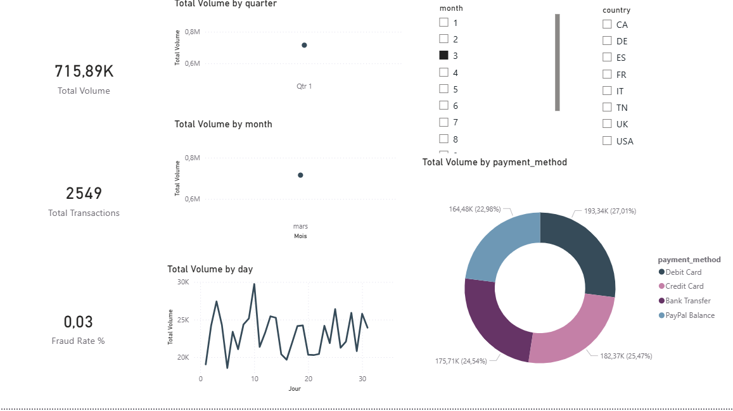
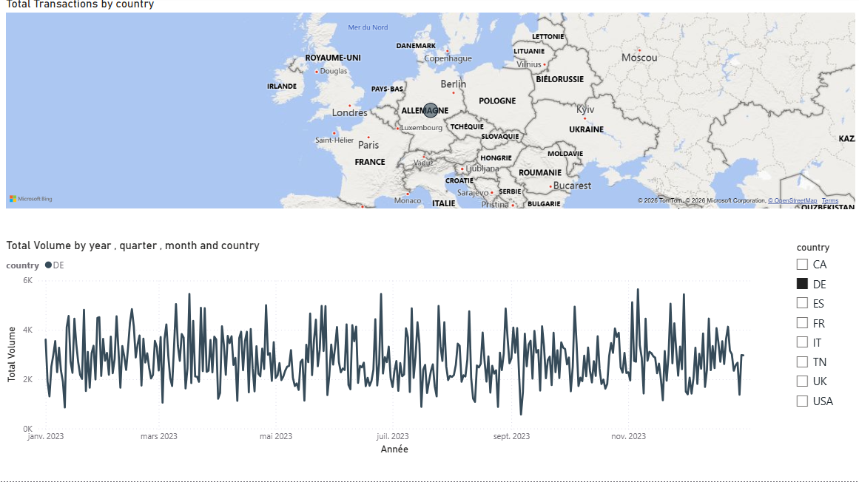

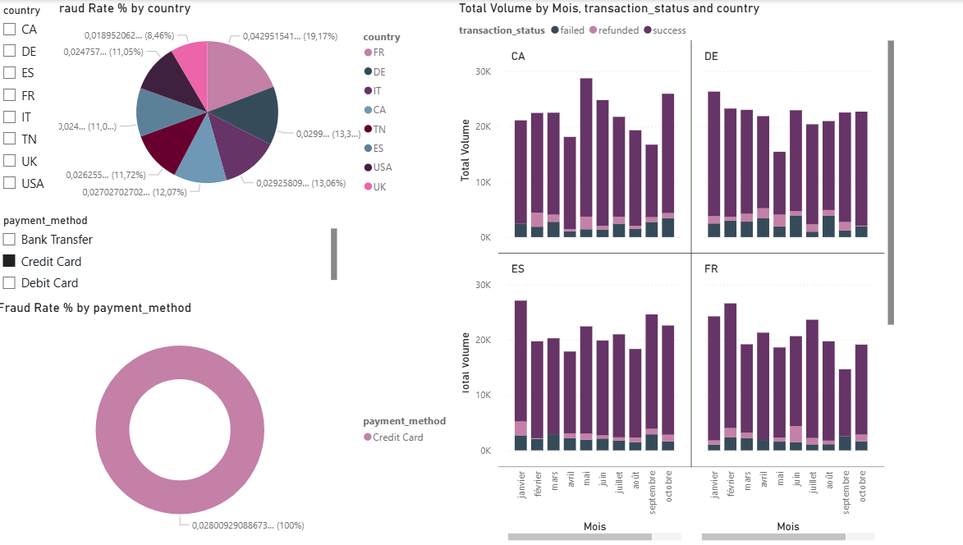

This appendix presents the Python script used to implement the Extract, Transform, and Load (ETL) process for the PayPal transaction dataset. The script was developed using the pandas library and was executed prior to data modeling and dashboard development in Power BI. The ETL process ensures data quality, consistency, and readiness for analytical use.

import pandas as pd

# Extract
raw_df = pd.read_csv("data_raw/paypal_transactions_raw.csv")

# Transform
df = raw_df.drop_duplicates(subset="transaction_id")
df["transaction_fee"] = df["transaction_fee"].fillna(0)
df["fraud_flag"] = df["fraud_flag"].fillna(0)
df["transaction_date"] = pd.to_datetime(df["transaction_date"])
df["transaction_amount"] = df["transaction_amount"].astype(float)

# Feature Engineering
df["year"] = df["transaction_date"].dt.year
df["month"] = df["transaction_date"].dt.month

# Load
df.to_csv("data_clean/paypal_transactions_clean.csv", index=False)

